**Introduction for the 3D game**

Three parts will be introduced in this article. They are unimplemented function, difference in setting between 3D game coded by MATLAB and that made with Unity, and how to play the 3D game written by Unity.

1. **Unimplemented function**

Saving data has not been implemented yet. The coding for how to save data has been studied. It won’t take too much time.

1. **Difference in setting between 3D game coded by MATLAB and that made with Unity (**Don’t worry, all the parameters are very easy to set**)**
2. In MATLAB coding, the paddle parameters are that width is 0.01m, height is 0.01m, and depth is 0.02m. The ball size is 0.08m. And the orbit radius of paddle is 0.1185m. In unity program, the paddle’s width, height and depth are 0.5m (expanded by 50 times), 0.5m (enlarged by 50 times) and 0.25m respectively. The ball size is 0.4m (increased by 50 times). And the paddle’s orbit radius is 10m.

**Reason**: The reason for extending the parameters is because the objects with previous setting look too small in the background, and the paddle is too close to the ball. The reason why the paddle depth is not expended by 50 times is because the paddle shape may look weird after expansion. The reason why the orbit radius of paddle is greater than 50 times is because if the distance becomes smaller (i.e. increased to 50 times), the probability of hitting ball will be improved greatly.

1. In MATLAB coding, the ball has a random speed. First, it moves for 1s. One second later, the ball will disappear. After pressing the Space Bar, it will appear and keep moving for 1s. In unity program, the ball speed is constant. At the beginning, the ball moves for 1s. Then it disappears. After pressing the Space Bar, the ball will show up and keep running for 1s.

**Reason**: I think constant ball speed is better.

1. **How to play the 3D game written by Unity (**Note: all the parameters are very easy to change**)**
2. Double click the 3Dgame.exe icon, a MessageBox pops up:

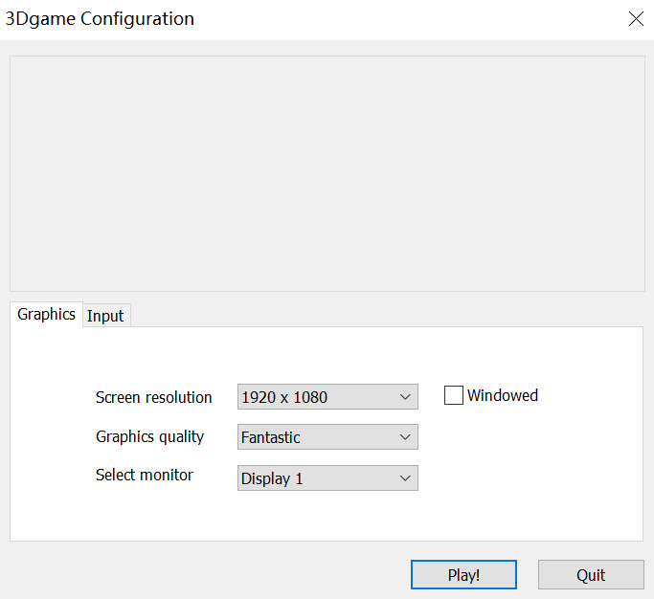

1. Select the corresponding option you want, then click the button Play!, the game interface pops up:

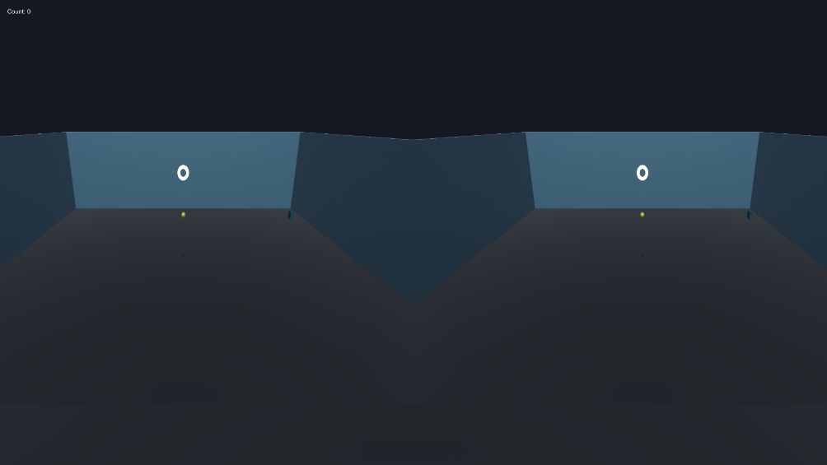

1. Explanation for the game interface:

The red box is the collision number between paddle and ball (count number starts from 0). The yellow box is the donut. The blue box is the ball. And the green box is the paddle.

1. Press the “up arrow” on the keyboard to launch the ball. The ball will move for 1s in a random direction. The constant speed is 5m/s. After 1s’ movement, the ball will vanish. Then press “left arrow” or “right arrow” on the keyboard to move paddle to the proper place. Press Space Bar for feedback. That is the ball will appear in the disappearing position and continue to move at original speed in original direction until it hits the paddle (feedback: cowbell, count number plus 1), or misses the paddle (feedback: swish). After the feedback, the ball and the paddle will return to their original positions and wait for the new trial. There are 225 trials in total. The pupil distance is 60mm. It can be increased or decreased by repeatedly pressing the “X” (increasing PD by 0.01m/times) and “Z” (decreasing PD by 0.01m/times) on the keyboard. Press “Esc” on the keyboard to exit the game.
2. The video for the 3D game (Note: the first and last few frames are starting and stopping the recording video software):

